**Project Management**

**Recreation and Wellness Intranet Project**

Project By

KHUSHI PATEL(703251398)

Contents

Introduction: 2

PART 1: Project Integration Management 2

Task 1: Summary of the proposed project at Manage Your Health, Inc. (MYH) 2

Task 2: Weighting Scoring Model Evaluation: 3

Task 3: Business case for Recreation and Wellness Intranet project: 4

Task 4: 5

PART2: Project Scope Management: 7

Task 1: Requirements traceability matrix: 7

Task 2: Scope statement: 7

Task 3: Work Breakdown Structure: 8

Task 4: Gantt Chart: 10

PART 3: Project Schedule Management 11

Task 1: Additional activities: 11

Task 2: Milestones for the Recreation and Wellness Intranet Project 11

PART 4: Project Cost and Quality Management 12

Task 4: 14

PART 5: Project resource and communication: 14

Task 1: Responsibility Assignment Matrix: 14

Task 2: Resource Histogram 15

Task 3: Communication media for HR support: 15

Task 4: Communication management plan: 15

PART 6: Project risk and procurement management: 17

Task 1: Risk register 17

Task 2: Probability and interest matrix 18

Task 3: Memo: 18

Task 4: Proposal selection: 19

# Introduction:

Manage Your Health, Inc. (MYH) is committed to offering state-of-the-art services globally, and it is at the forefront of healthcare innovation. MYH, which employs more than 25,000 people, has updated its strategy plan with a focus on cost-cutting, improved cross-selling, and utilizing digital technologies for more efficient operations. The context for discussing MYH's large-scale initiatives to enhance worker well-being, reduce healthcare costs, increase sales efficiency, and transform customer communications is provided by this introduction. MYH hopes to uphold its reputation of revolutionary healthcare delivery and reaffirm its dedication to excellence through these projects.

# PART 1: Project Integration Management

# Task 1: Summary of the proposed project at Manage Your Health, Inc. (MYH)

|  |  |  |  |  |
| --- | --- | --- | --- | --- |
| **Project name** | **Business strategy support** | **Financial benefits** | **Other benefits** | **Initial assessment** |
| Recreation and wellness Intranet project | Their business strategy is to reduce internal costs by lowering healthcare premiums | Over four years, full-time employees are expected to save at least $30 each year. | Better employee health and morale | High value because of the substantial potential savings and advantages for employee wellness |
| Health coverage costs business model | Their business strategy is to reduce internal costs by optimizing healthcare expenses | Over four years, full-time employees are expected to save roughly $20 each year on average. | Improved capacity for data analysis and policy revision | Moderate value taking into account modest savings and the advantages of data analysis |
| Cross spelling system | The strategy followed by the project is to increase the cross-selling of products and services | An estimated $1 million more in profits per year for the next three years | Increased client loyalty and satisfaction | High value because of the large potential for profit growth |
| Web-enhanced communication system | This project aims to exploit the new web-based technologies for better service delivery | An estimated $2 million in savings per year over a period of three years | Enhanced communications between suppliers and customers | High value because of significant potential savings and enhanced services |

# Task 2: Weighting Scoring Model Evaluation:

Four evaluation criteria will be developed us:   
  
A. Strategic Alignment: To what extent does the project meet the strategic objectives of MYH?   
B. Financial Gains or Savings: What are the project's possible financial gains or savings?   
C. Feasibility: In terms of execution and upkeep, how feasible is the project?   
D. Impact on Stakeholders: How might the project affect the involvement and satisfaction of stakeholders?

E. Innovation potential: How much potential is in his project?

F. Time to market: What is the projected time to bring the project to market?

G. Risk mitigation: Does the project have a robust risk mitigation plan?

**Criteria Weights:**

1. Strategic Alignment: 30%
2. Financial Benefits: 35%
3. Feasibility: 20%
4. Stakeholder Impact: 15%
5. Innovation potential: 10%
6. Time to market: 15%
7. Risk mitigation: 20%

|  |  |  |  |  |  |
| --- | --- | --- | --- | --- | --- |
| **Weighted Scoring Model for Project MYH** | | | | | |
| **Created by: Project manager** | **Date:** | 13/05/2024 |  |  |  |
| **Note: Enter your criteria, weights, and scores in the template below.** | | | | |  |
| **Insert or clear rows and columns as needed. Double-check formulas and results.** | | | | | |
|  |  |  |  |  |  |
| **Criteria** | **Weight** | **Project 1** | **Project 2** | **Project 3** | **Project 4** |
| A | 20% | 80 | 70 | 85 | 90 |
| B | 25% | 85 | 90 | 95 | 80 |
| C | 15% | 75 | 80 | 70 | 85 |
| D | 15% | 70 | 65 | 80 | 75 |
| E | 10% | 85 | 75 | 90 | 80 |
| F | 10% | 70 | 80 | 85 | 75 |
| G | 5% | 80 | 75 | 70 | 85 |
| **Weighted Project Scores** | **100%** | **78.5** | **77.5** | **84.25** | **81.75** |
|  |  |  |  |  |  |

# Task 3: Business case for Recreation and Wellness Intranet project:

**Business Case for Recreation and Wellness Intranet Project**

**Date: 13-5-24**

**Project Name: Recreation and Wellness Intranet Project**

|  |
| --- |
| 1. **Introduction/ Background**   Manage Your Health, Inc., or MYH, is aware of how important worker health is to creating a productive workplace. The Recreation and Wellness Intranet Project aims to improve employee health and reduce the company's high healthcare costs by providing conveniently accessible recreational and wellness services. |
| **2.0 Business Objective**  The project's main goal is to cut internal expenses by enhancing employee health and well-being and, as a result, negotiating cheaper MYH healthcare prices. |
| **3.0 Current Situation and Problem/Opportunity Statement**  MYH pays 20% more in healthcare premiums than the industry average due to the ill health of its employees. Employers can address the root cause of high healthcare costs by implementing a Recreation and Wellness Intranet, which provides easy access to company-sponsored recreational programs and health-management resources for employees. |
| **4.0 Critical Assumptions and Constraints**  **Assumptions:** The wellness and recreational initiatives will be enthusiastically embraced by the workforce.  All staff members will be able to easily navigate and use the intranet platform.  **Constraints**:  Limited budget of $200,000.  Timeline for completion: six months. |
| **5.0 Analysis of Options and Recommendation**  The Recreation and Wellness Intranet Project is the most workable solution to improve employee health and well-being while addressing the issue of excessive healthcare costs. It aligns with MYH's strategic goals of reducing internal costs and increasing employee satisfaction. |
| **6.0 Preliminary Project Requirements**   * Creation of an intranet platform that is easy to use. * Integration of recreational program tracking and registration features. * Resources for health management and incentives for staff involvement are included. |
| **7.0 Budget Estimate and Financial Analysis**  Project Funding: $200,000.  Estimated Cost Savings: Over a four-year period, full-time employees will save at least $30 each year. |
| **8.0 Schedule Estimate**  Months 1-2: Planning and Design  Months 3-4: Development and Testing  Month 5: Pilot Testing and Training  Month 6: Full Implementation and Launch |
| **9.0 Potential Risks**   * Low rates of employee involvement. * Obstacles of a technical nature when developing an intranet. * Delays or overruns in the budget. |
| **10.0 Exhibits**  Exhibit A: Financial Analysis   |  |  | | --- | --- | | Financial metrics | Amount | | Estimated annual cost savings per employee | $30 | | Number of full-time employees | $20,000 | | Total estimated annual cost savings | $600,000 | | Total project cost | $200,000 | | Net savings over four years | $2400,000 | | Return on investment (ROI) | 1100% | | Payback period | Approximately 4 months | |

# Task 4:

|  |  |  |  |
| --- | --- | --- | --- |
| **Project Title**: Recreation and Wellness Intranet project | | | |
| **Project Start Date: 05-17-24 Projected Finish Date:** 15-19-24 | | | |
| **Budget Information:**  **$200,000** | | | |
| **Project Manager:** Tom Cruise CruiseTom@gmail.com | | | |
| **Project Objectives:**  • Create an easy-to-use intranet portal to promote the wellbeing of employees.  • Provide access to company-funded resources for health management and recreational activities for employees. | | | |
| **Success Criteria:**  • A greater interest in recreational activities among employees.  • A decrease in MYH health insurance costs.  • Better indicators of workers' health and happiness. | | | |
| **Approach:**   * + Perform a needs assessment to find out what sorts of recreational activities your staff love.   + Develop and implement a user-friendly intranet platform with tools for registration and tracking.   + To encourage employee engagement, include resources and incentives for health management.   To support and progress the project, collaborate with the HR and wellness committees. | | | |
| **Roles and Responsibilities** | | | |
| ***Name and Signature*** | ***Role*** | ***Position*** | ***Contact Information*** |
| **Khushi** | **Project manager** | **Project manager** | [**Khushi@gmail.com**](mailto:Khushi@gmail.com) |
| **Abigail** | **Quality analyst** | **Quality assurance officer** | [**Abigail@gmail.com**](mailto:Abigail@gmail.com) |
| **Viraj** | **IT specialist** | **IT support technician** | [**Viraj@gmail.com**](mailto:Viraj@gmail.com) |
| **Vrunda** | **Project sponsor** | **Project sponsor** | [**Vrunda@gmail.com**](mailto:Vrunda@gmail.com) |
| **Tom Cruise** | **HR representative** | **Human resource coordinator** | **CruiseTom@gmail.com** |
|  | | | |
| **Comments:** (Any further feedback or comments from stakeholders may be included here, either in the writing stage or following preliminary reviews.) | | | |

# PART2: Project Scope Management:

# Task 1: Requirements traceability matrix:

|  |  |  |  |  |
| --- | --- | --- | --- | --- |
| **Requirement No.** | **Name** | **Category** | **Source** | **Status** |
| **1** | Registration for recreational programs | Functional | Surveys, stakeholder interviews | Active |
| **2** | Registration for health management programs | Functional | Surveys, stakeholder interviews | Pending |
| **3** | Tracking employee involvement | Functional | Surveys, stakeholder interviews | Pending |
| **4** | Incentives for program participation | Functional | Surveys, stakeholder interviews | Pending |
| **5** | User-friendly interface | Non-Functional | Focus groups and user stories | Pending |
| **1** | Registration for recreational programs | Functional | Surveys, stakeholder interviews | Active |

# 

# Task 2: Scope statement:

|  |
| --- |
| **Project Title: Recreation and Wellness Intranet project**  **Date: 17-5-24** **Prepared by:** project manager |
| **Project Justification:**  Through easily accessible recreational programs and health-management materials, the Recreation and Wellness Intranet Project seeks to promote employee health and well-being in order to alleviate Manage Your Health, Inc.'s (MYH) exorbitant healthcare costs. Through the provision of an intuitive intranet platform, MYH aims to save healthcare expenses while simultaneously raising employee contentment and optimizing organizational performance.  . |
| **Product Characteristics and Requirements:**   1. Registration for recreational programs 2. Registration for health-management programs 3. Tracking employee involvement 4. Incentives for program participation |
| **Product User Acceptance Criteria:**   * Recreational and health-management program registration should be simple and straightforward. * Workers ought to have access to the intranet system from a variety of gadgets and places. * The system ought to precisely monitor staff participation in initiatives and incentives obtained. * Workers should express great satisfaction with the intranet platform's usability and efficacy.   **Summary of Project Deliverables**  **Project management-related deliverables:** business case, charter, team contract, scope statement, WBS, schedule, cost baseline, status reports, final project presentation, final project report, lessons-learned report, and any other documents required to manage the project.  **Product-related deliverables:** research reports, design documents, software code, hardware, etc.   1. Research reports 2. Design Documents 3. Software code 4. Hardware (If applicable) |

# Task 3: Work Breakdown Structure:

**Project Name:** Recreation and Wellness Intranet project

1. Project planning and analysis

1.1 need assessment

1.2 Project Scope Statement

1.2.1 Gather requirements for recreational programs

1.2.2 Collect Requirements for the Health Management Program

1.3 Analysse current systems and processes

1.4 identify project risks and constraints

1. Design and development

2.1 develop an intranet platform architecture

2.2 design user interface and registration system

2.2.1 design registration model for the recreational program

2.2.2 Design Registration Module for health-management Programs

2.3 develop a tracking mechanism for employee involvement

2.4 implement incentive system for participation

1. Implementation and testing
   1. Build intranet platform infrastructure
   2. Integrate registration and tracking functionalities

3.2.1 integrate registration system for recreational programs

3.2.2 integrate registration system for health-management program

* 1. Conduct user acceptance testing
  2. Refine and finalize the system based on feedback

1. Deployment and maintenance
   1. Roll out intranet platform to MYH employees
   2. Provide training and support for platform usage
      1. Establish maintenance procedures and support channels
      2. Monitor system performance and user feedback
   3. Perform regular updates and maintenance tasks
   4. Document system architecture and user guidelines

# Task 4: Gantt Chart:

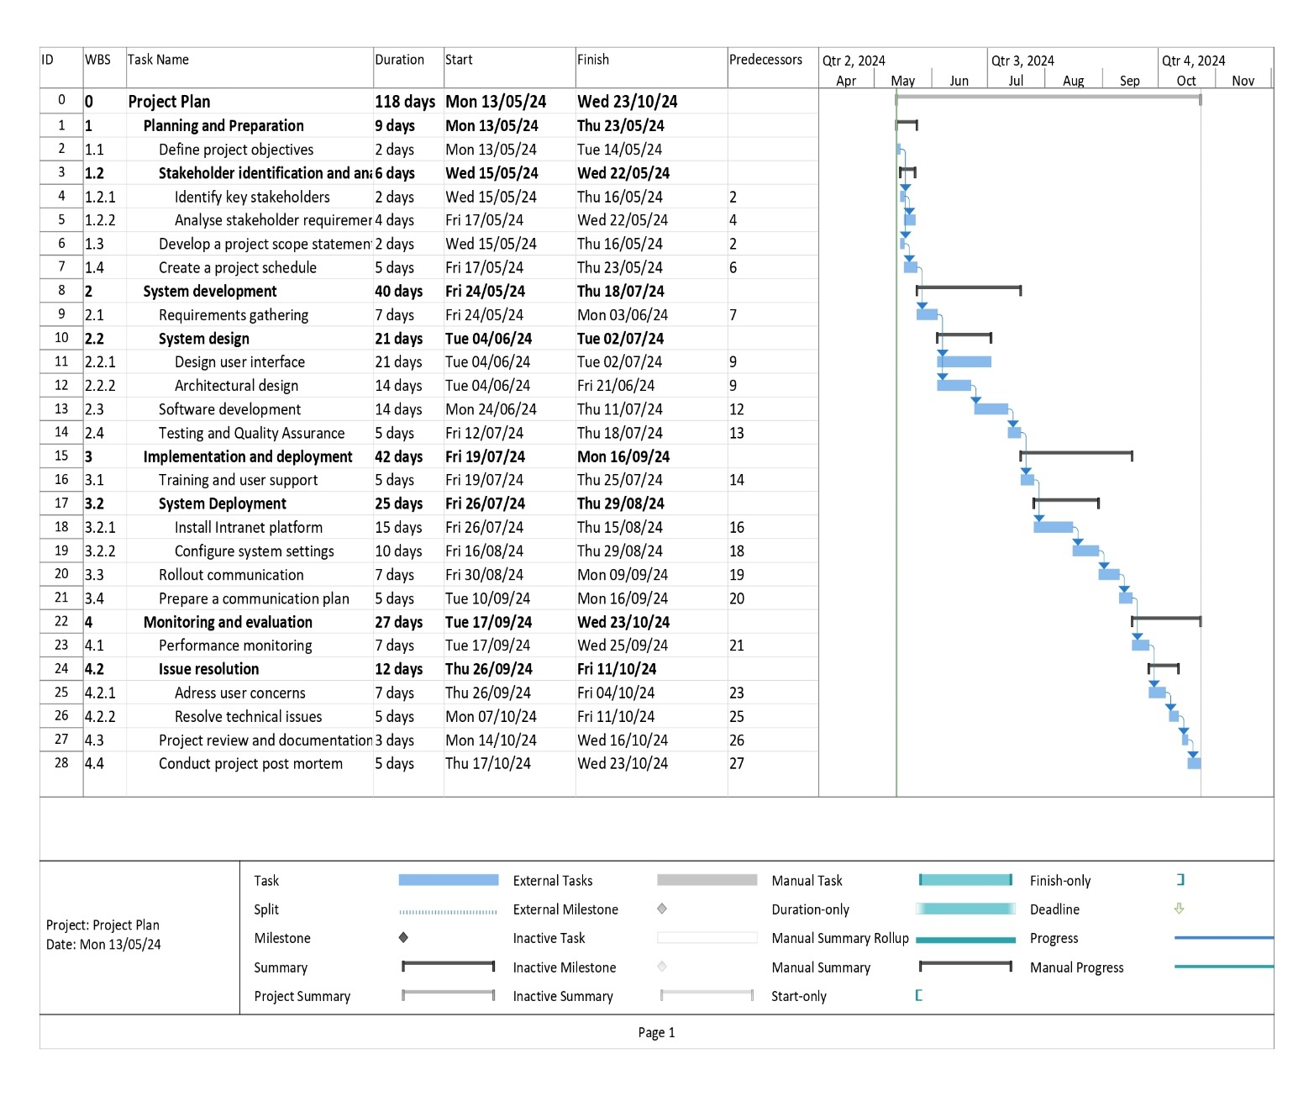MS Project Software has been used for Gantt Chart the Project Gantt Chart shown below.

# PART 3: Project Schedule Management

## Task 1: Additional activities:

The project plan could incorporate the following extra actions to improve resource and duration estimation:

1. **Resource Allocation and Identification**: Prior to beginning a thorough resource estimation, it is crucial to determine which resources are needed for each activity and to assign them appropriately. This work entails going over the project specifications, figuring out what skill sets are required, and allocating particular team members or outside resources to each task.
2. **Resource Skill Assessment**: Accurately forecasting task durations requires evaluating the skill levels of both external resources and team members. This role entails assessing the knowledge and experience of the people allocated to each task, determining any skill gaps that require filling in, and making any necessary plans for support or training.
3. **Risk assessment and mitigation planning:** Estimating more realistic timelines and resource needs might be aided by taking possible risks and uncertainties into account up front. This task entails carrying out a comprehensive risk assessment, spotting possible risks to the project schedule, and creating proactive mitigation plans to deal with those threats.

## Task 2: Milestones for the Recreation and Wellness Intranet Project

Milestone 1:

* Specific: Completion of Requirements Gathering   
  Particulars: Compile all features, functionalities, and user requirements required for the Recreation and Wellness Intranet Project.
* Measurable: Verify that every important stakeholder has offered feedback and approved the requirements that have been obtained.
* Achievable: Gather thorough requirements in the allotted time by using a variety of methods, including workshops, questionnaires, and interviews.
* Relevant: The requirements gathering process must be completed in order to provide guidance for the system design, development, and implementation phases that follow.
* Time-bound: Establish a deadline for finishing the requirements collection process and make sure it fits within the project's overall plan.
* System Design completion (Milestone 2):   
  Particulars: Create a thorough system design that includes the architecture, user interface, and technological requirements for the Recreation and Wellness Intranet Project.   
  Measurable: Ascertain that every design element is accurately recorded and vetted by pertinent stakeholders to ensure it complies with project goals.   
  Achievable: To build a solid system design that satisfies project requirements and constraints, apply recognised design processes and best practices.   
  Relevant: The system design's completion offers a roadmap for the project's development and implementation stages.   
  Time-bound: Establish a timeframe for finishing system design tasks while taking dependencies and resource availability into consideration.

**Task 3:**

The updated Gantt Chart is given below:

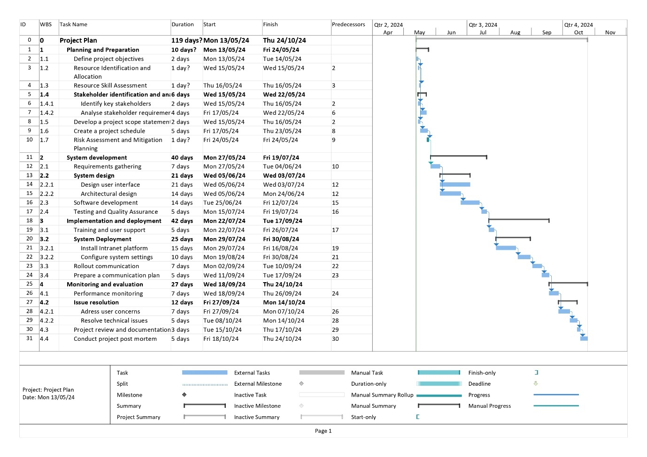

# PART 4: Project Cost and Quality Management

**Task 1:**

|  |  |  |  |  |  |  |  |
| --- | --- | --- | --- | --- | --- | --- | --- |
| **Cost Estimate** | | | | | | | |
| **Project Name:** | **Date:** |  |  |  |  |  |  |
| **WBS Categories** | **Internal Labor** | | | **External Labor** | | | **Total Cost** |
| **Hours** | **Rate** | **$ Total** | **Hours** | **Rate** | **$ Total** |
| 1. Project management | 200 | $ 100 | **$20,000** |  |  | **$ -** | $ 20,000 |
| 2. Requirements definition | 600 | $ 60 | **$36,000** |  |  | **$ -** | $ 36,000 |
| 3. Web site design |  |  | **$ -** |  |  | **$ -** | $ - |
| 3.1 Registration for recreational programs | 300 |  | **$ -** |  |  | **$ -** | $ - |
| 3.2 Registration for classes and programs | 100 | $ 60 | **$ 6,000** | 10 | $ 60 | **$ 600** | $ 6,600 |
| 3.3 Tracking system | 300 | $ 60 | **$18,000** | 24 | $ 60 | **$ 1,440** | $ 19,440 |
| 4. Web site developmen |  | $ 60 | **$ -** | 8 | $ 60 | **$ 480** | $ 480 |
| 4.1 Registration for recreational programs | 400 | $ 60 | **$24,000** | 16 | $ 60 | **$ 960** | $ 24,960 |
| 4.2 Registration for classes and programs | 400 | $ 60 | **$24,000** | 24 | $ 60 | **$ 1,440** | $ 25,440 |
| 4.3 Tracking system | 300 | $ 60 | **$18,000** |  |  | **$ -** | $ 18,000 |
| 4.4 Incentive system | 300 | $ 60 | **$18,000** |  |  | **$ -** | $ 18,000 |
| 5. Testing | 300 | $ 60 | **$18,000** |  |  | **$ -** | $ 18,000 |
| 6. Training, rollout, and support | 200 | $ 60 | **$12,000** |  |  | **$ -** | $ 12,000 |
| Subtotal |  |  |  |  |  |  | $ - |
| Reserves |  |  | **$ -** |  |  | **$ -** | $ - |
| **Total** | 3,400 |  | **194,000** | 82 | 300 | **4,920** | **$ 198,920** |

**Task 2:**

|  |  |  |  |  |  |  |  |
| --- | --- | --- | --- | --- | --- | --- | --- |
| **Month** | **Project Management** | **Requirements Definition** | **Web Site Design** | **Web Site Development** | **Testing** | **Training, Rollout, and Support** | **Total Cost** |
| Month 1 | $16,487 | $6,000 | $0 | $1,500 | $3,000 | $2,000 | $29,987 |
| Month 2 | $16,487 | $6,000 | $0 | $1,500 | $3,000 | $2,000 | $29,987 |
| Month 3 | $16,487 | $6,000 | $0 | $1,500 | $3,000 | $2,000 | $29,987 |
| Month 4 | $16,487 | $6,000 | $0 | $1,500 | $3,000 | $2,000 | $29,987 |
| Month 5 | $16,487 | $6,000 | $0 | $1,500 | $3,000 | $2,000 | $29,987 |
| Month 6 | $16,487 | $6,000 | $0 | $1,500 | $3,000 | $2,000 | $29,987 |
| **Total** | **$98,922** | **$36,000** | **$0** | **$9,000** | **$18,000** | **$12,000** | **$174,922** |

**Task 3:**

|  |  |  |
| --- | --- | --- |
| **Parameter** | **Calculation** | **Result** |
| **Cost Variance (CV)** | **EV - AC** | **$10,000** |
| **Schedule Variance (SV)** | **EV - PV** | **-$20,000** |
| **Cost Performance Index (CPI)** | **EV / AC** | **1.11** |
| **Schedule Performance Index (SPI)** | **EV / PV** | **0.83** |
| **Estimate at Completion (EAC)** | **BAC / CPI** | **$180,180.18** |
| **Estimate of Time to Completion (ETC)** | **(BAC - EV) / (SPI * EV)** | **$120,481.93** |

# Task 4:

**User Engagement Rate:** Within two weeks of the system's launch, at least 90% of employees should be logging in. This guarantees a high level of user participation and intranet platform adoption.

**System Reliability:** During regular business hours, the system should be up 99.9% of the time. This guarantees that there won't be frequent outages and that customers may access the system with reliability.

**Data Accuracy:** 98% or more accuracy is required for data entered into the system. This guarantees that the system's information is trustworthy and dependable for making decisions.

**Performance Speed:** On average, the system should take three seconds to load pages and react to user input. By doing this, a flawless user experience is guaranteed and annoyance from sluggish performance is avoided.